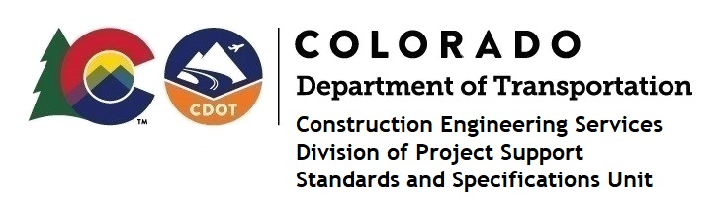

MEMORANDUM

DATE: December 29, 2020

TO: All holders of Standard Special Provisions

FROM: Shawn Yu, Standards and Specifications Unit Manager

SUBJECT: Revised standard special provision: Revision of Section 107 – Water Quality

Control

Effective this date, our unit has issued the revised standard special provision, Revision of Section 107 – Water Quality Control, with 6 pages, and dated December 29, 2020. It has replaced the December 28, 2020 specification with same name.

This specification revised subsection 107.25 - Water Quality Control.

Please use this provision on all projects not having a Federal, State or Local Stormwater Construction Permit (projects with less than one acre of disturbance and not part of a common plan of development), beginning with projects advertised on or after January 24, 2021. Earlier use is acceptable.

For those of you who keep a book of Standard Special Provisions, please include this new special provision. For your convenience, this specification and the latest SSP Index are attached in the email. You can also find these in our Construction Specifications web pages: Standard Special Provisions and the Recently Issued Special Provisions.

If you have any questions or comments, please contact this office.

